Hi, below bug report shows the bugs in “Buggy Rating” website. Done testing for this web application by using Google Chrome web browser. The below mentioned first three bugs are in Jira bug format.

1. Bug Name: “Buggy Rating” link is broken in “Popular Make” web page.

Bug id: BM-1234

**Details**

Type: Bug

Priority: Critical

Affects version/s: 1.0.0

Labels: Buggyteam

Status: To Do

Resolution: Unresolved

Fix version/s: None

**People**

Assignee: Brendon M

Reporter: Bhasker T

**Description**

Unable to access “Buggy Rating” home page from “Popular Make” category web page while clicking on “Buggy Rating”, as the link is broken.

Steps to Reproduce:

1. Log into <https://buggy.justtestit.org/> with valid credentials.
2. Navigate to “Popular Make” category.
3. Click on “Buggy Rating” which is on the top left side in the web page to navigate back to home page.

Expected Results: On clicking “Buggy Rating”, should be able to navigate to “Buggy Rating” home page

Actual Results: “Buggy Rating” link is broken so unable to navigate to “Buggy Rating” home page.

**Attachment**

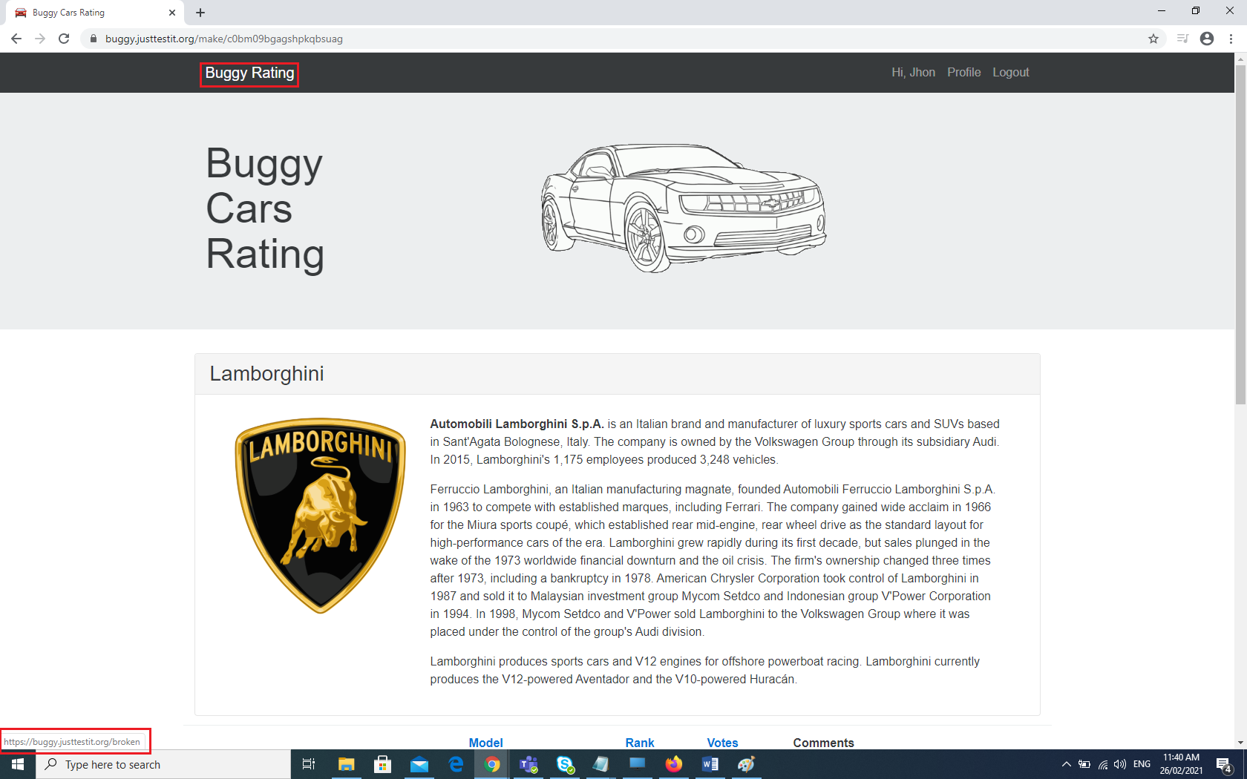

1. Bug Name: “Buggy Rating” website is not working as expected in few web browsers like Firefox and Microsoft Edge. (Cross browser testing)

***Requirement assumption here is, this website should work in any web browser.***

Bug id: BM-5678

**Details**

Type: Bug

Priority: Critical

Affects version/s: 1.0.0

Labels: Buggyteam

Status: To Do

Resolution: Unresolved

Fix version/s: None

**People**

Assignee: Brendon M

Reporter: Bhasker T

**Description**

Unable to access so many links from different web pages when we access “Buggy Rating” website in Internet Edge web browser as compared to Chrome browser. The same issue is there in Firefox web browser as well.

Example: 1. No model web page (for example: Diablo) is opening from “Popular Make” category page.

2. “Popular Model” is not accessible from the “Buggy Rating” web page.

3. No model web pages are opening from “Overall Rating” web page.

Steps to Reproduce:

1. Log into <https://buggy.justtestit.org/> in Internet Edge web browser.
2. Navigate to “Popular Make” category.
3. Click on “Diablo” model to navigate to that model.

Expected Results: On clicking “Diablo” model, should be able to navigate to “Diablo” model page.

Actual Results: “Diablo” model web page was not opened in Microsoft Edge browser. These issues are there in Firefox web browser as well and they are opening fine in Chrome.

**Attachment**

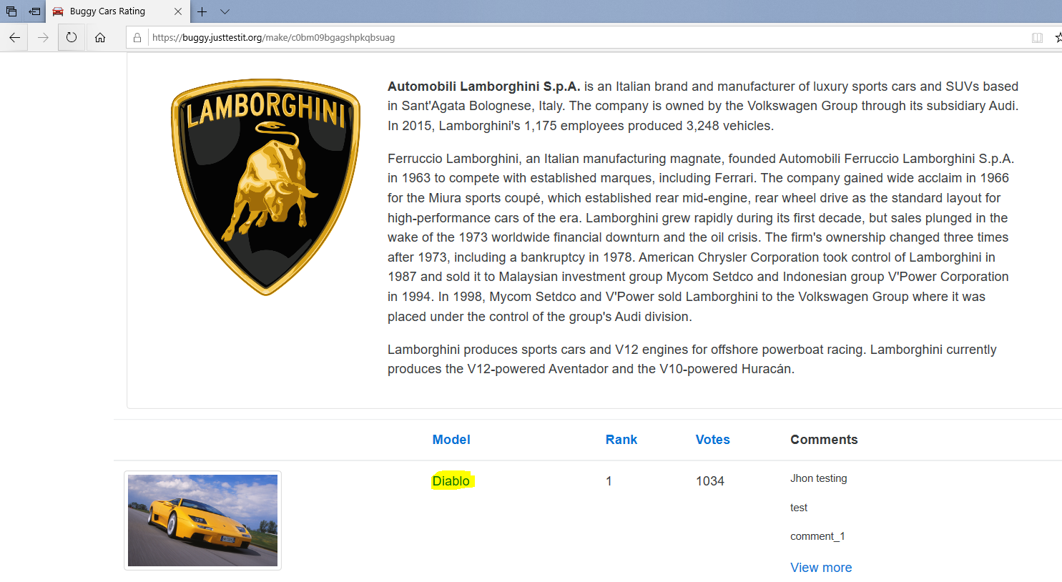

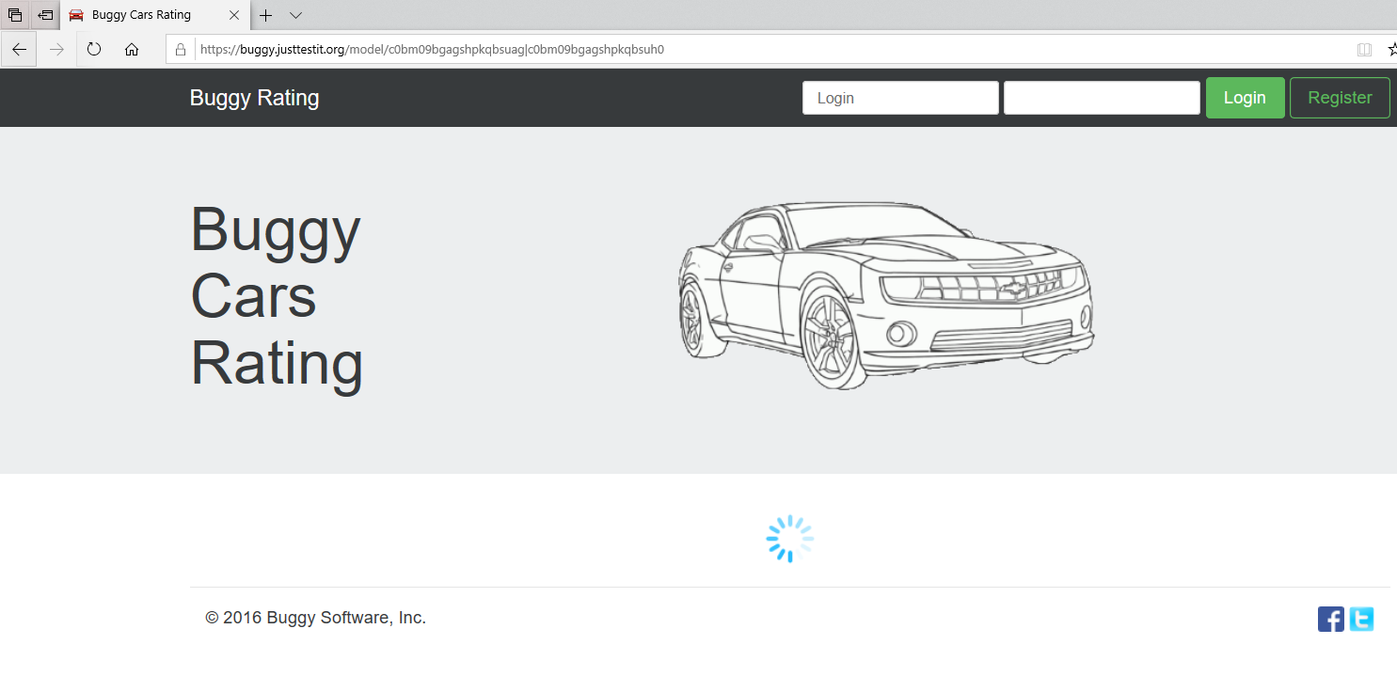

1. Bug Name: Registration page is still showing after logged into “Buggy Rating” website.

Bug id: BM-9000

**Details**

Type: Bug

Priority: Medium

Affects version/s: 1.0.0

Labels: Buggyteam

Status: To Do

Resolution: Unresolved

Fix version/s: None

**People**

Assignee: Brendon M

Reporter: Bhasker T

**Description**

After completing the registration and logged into “Buggy Rating” website with valid credentials. Instead of showing “Buggy Rating” home page still it is in Registration page only.

Steps to Reproduce:

1. Open <https://buggy.justtestit.org/> website.
2. Click on “Register” and create the login.
3. Enter valid login, password and click on “Login” button.
4. After logged in also, still showing Registration form.

Expected Results: After logged into “Buggy Rating” website, it should be able to navigate to “Buggy Rating” home page

Actual Results: Still showing Registration page instead of going to “Buggy Rating” home page.

**Attachment**

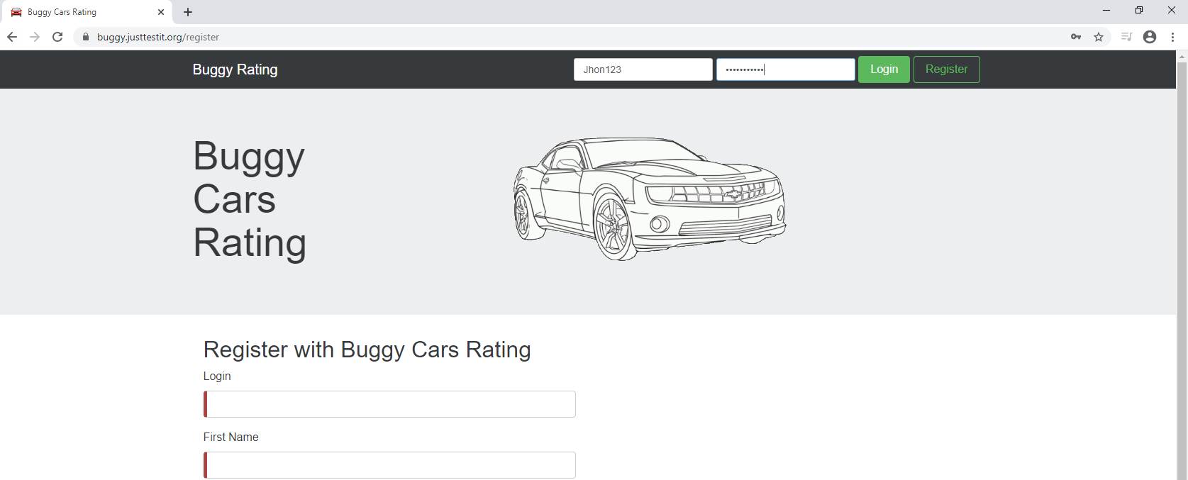

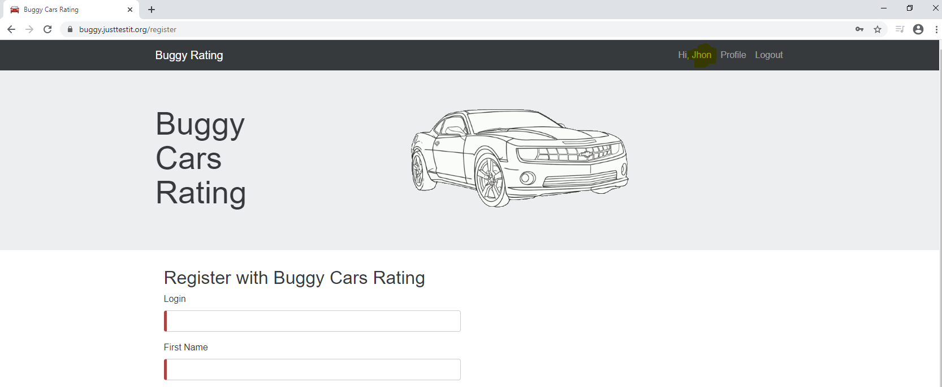

**Apart from above critical bugs there are few more bugs identified. Please check the below list of bugs:**

1. **Bug description: “**Buggy Rating” is not accessible in home page as shown in below link:

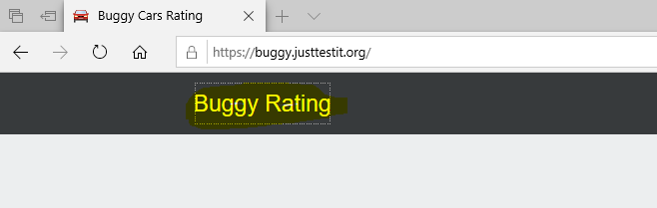

1. **Bug description:** The Lamborghini image in the below link is not accessible.

<https://buggy.justtestit.org/make/c0bm09bgagshpkqbsuag>

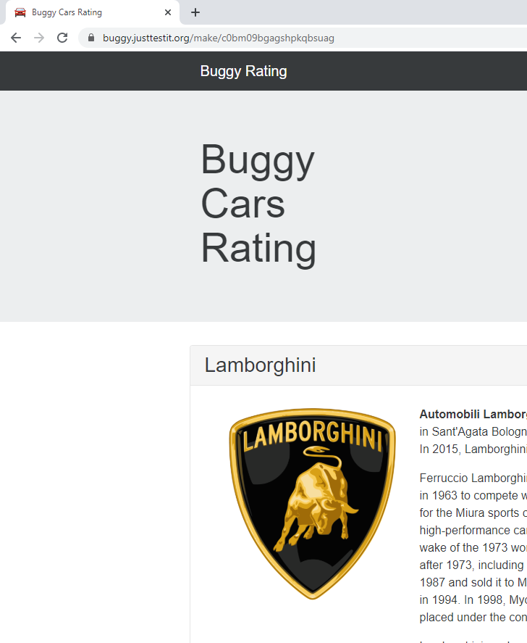

1. **Bug description:** On the home page, Login box required type is showing but nothing is showing in the password input box.

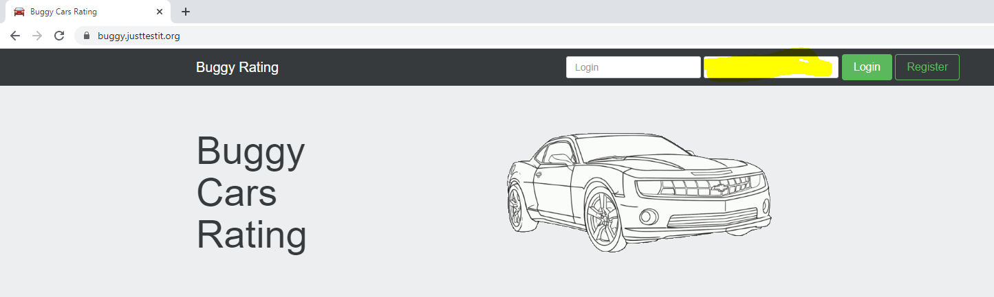

1. **Bug description:** There are no guidelines for password and login user in Register page. Username is case sensitive here.

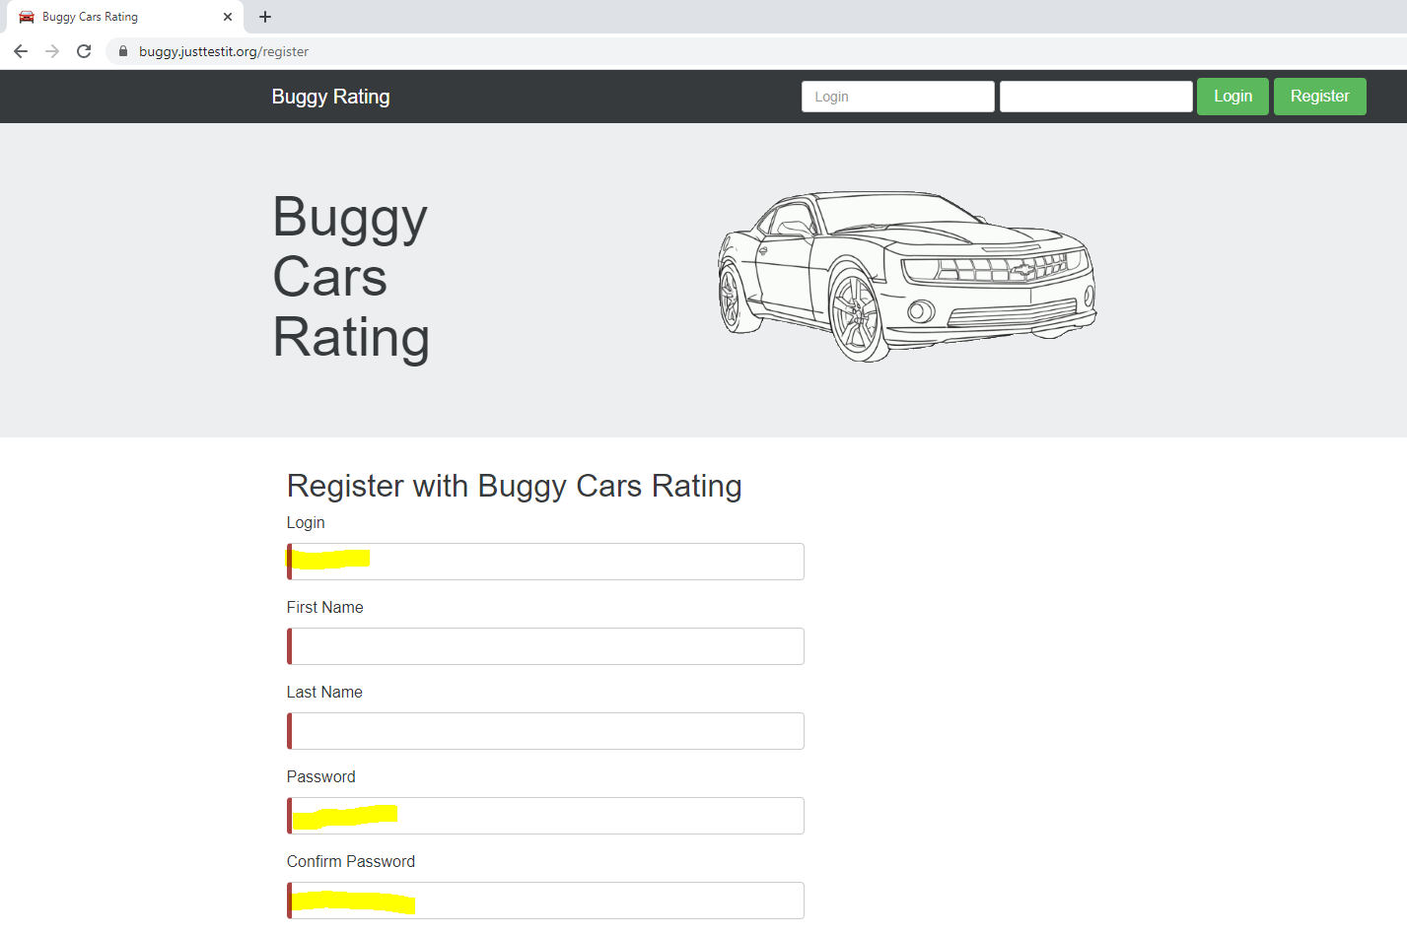

1. **Bug description:** If we click any car model image, example Diablo it is redirecting to BuggyCarsRating home page rather than enlarging the Diablo image in below link:

<https://buggy.justtestit.org/model/c0bm09bgagshpkqbsuag%7Cc0bm09bgagshpkqbsuh0>

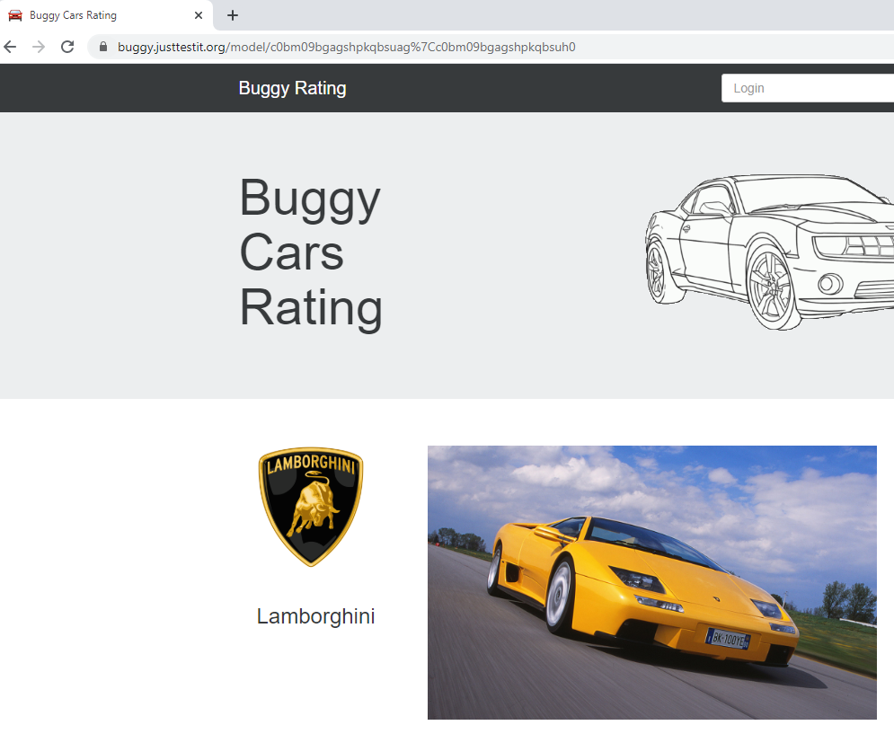

1. **Bug description:** Actual number of web pages are 5 but still it is allowing to navigate further under Overall Rating.

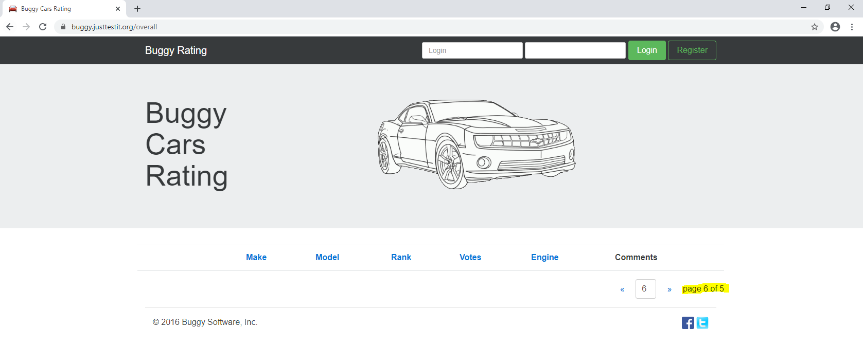

1. **Bug description:** When trying to search for list of cars by using search option we could able to search and navigate to 2,3 and 4 web pages but search is not working for 1 and 5 in “Overall Rating”.

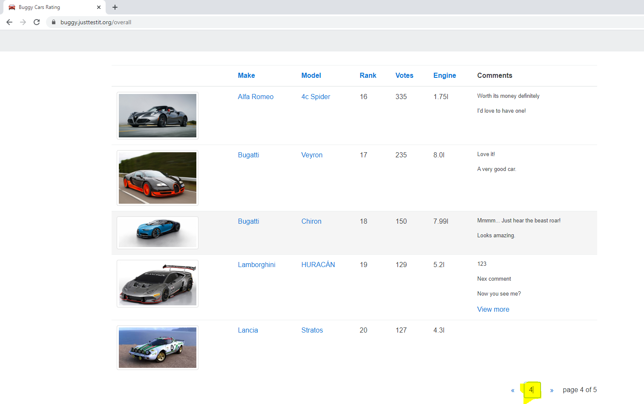

1. **Bug description:** After searching 2 or 3 or 4 web pages by using below shown search option and then try to navigate to the next page by using forward arrow link then it is redirecting to 21 or 31 or 41 respectively.

<https://buggy.justtestit.org/overall>

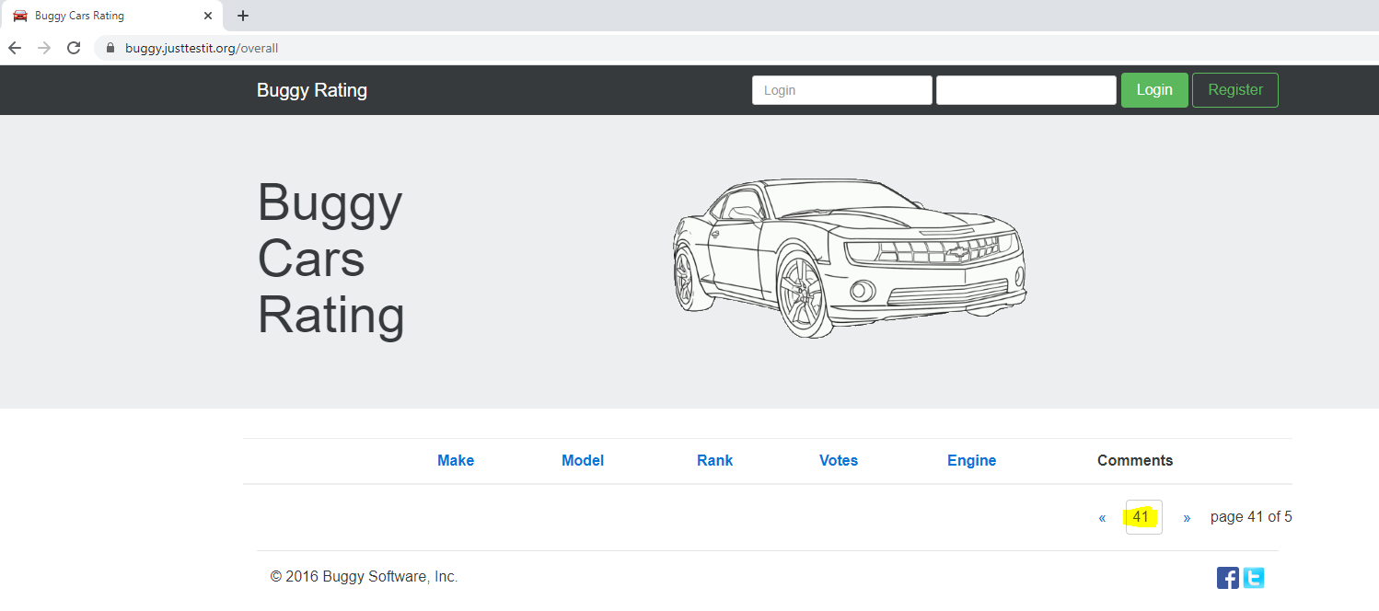

1. **Bug description:** Car models are not ordering properly on Rank. If we click on Rank, the ordering is restricted to that particular page but ordering is not happening to all the pages.

<https://buggy.justtestit.org/overall>

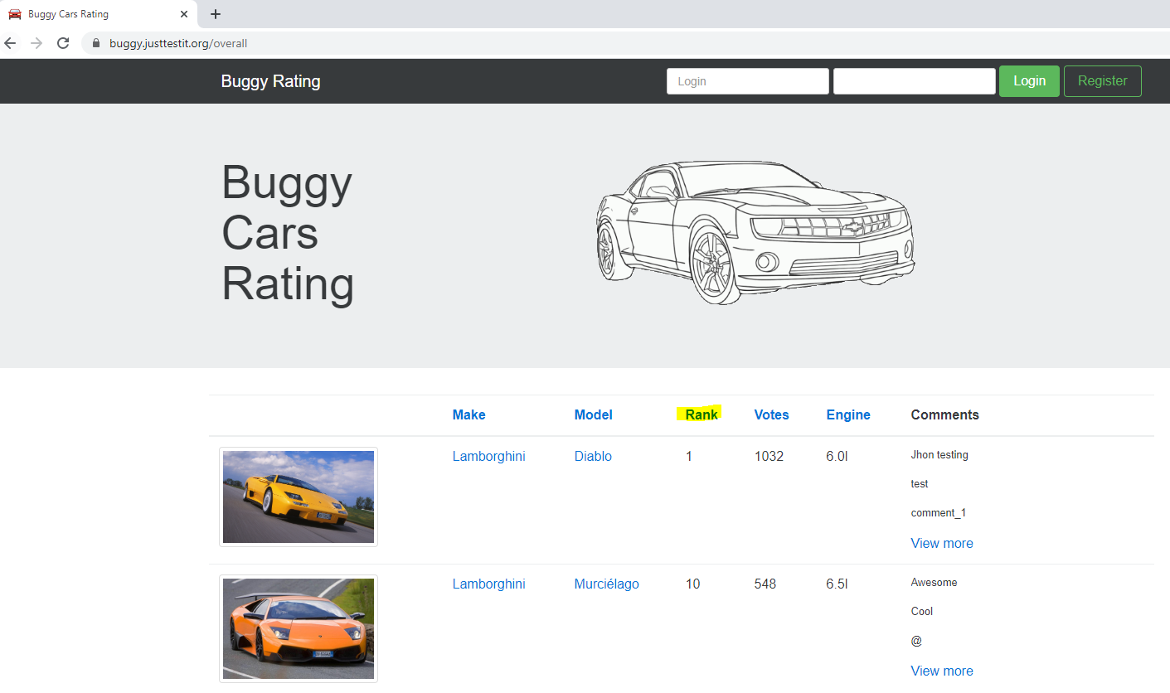

1. **Bug description:** For few of the car models there is no **View more** option to update the vote.

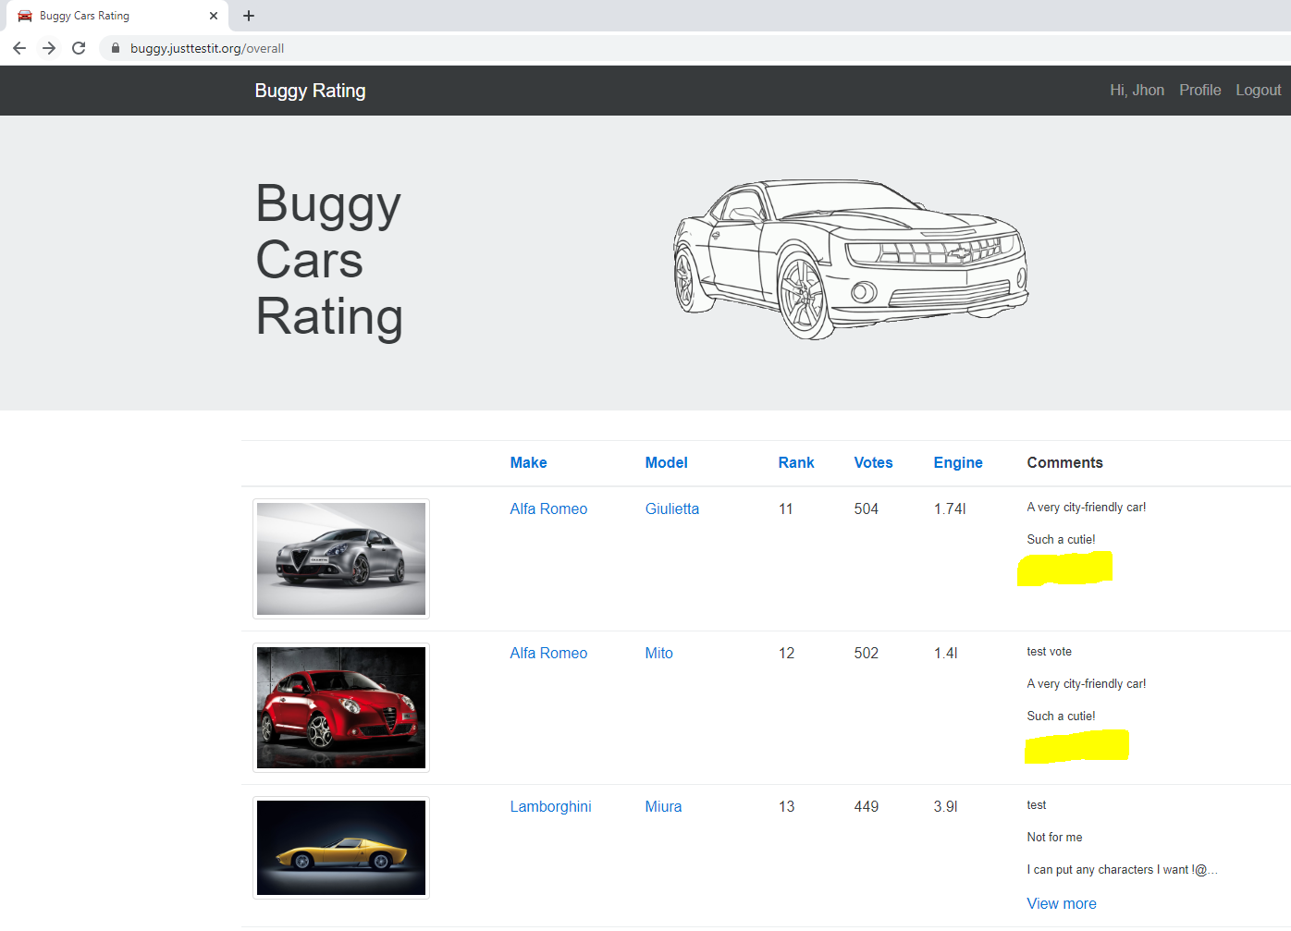

1. **Bug description:** If we click on Stratos car model which is under Lancia make model, then in the next page we can’t see the models images and description. Voted with one comment but it is also not reflecting there means no comments section**.**

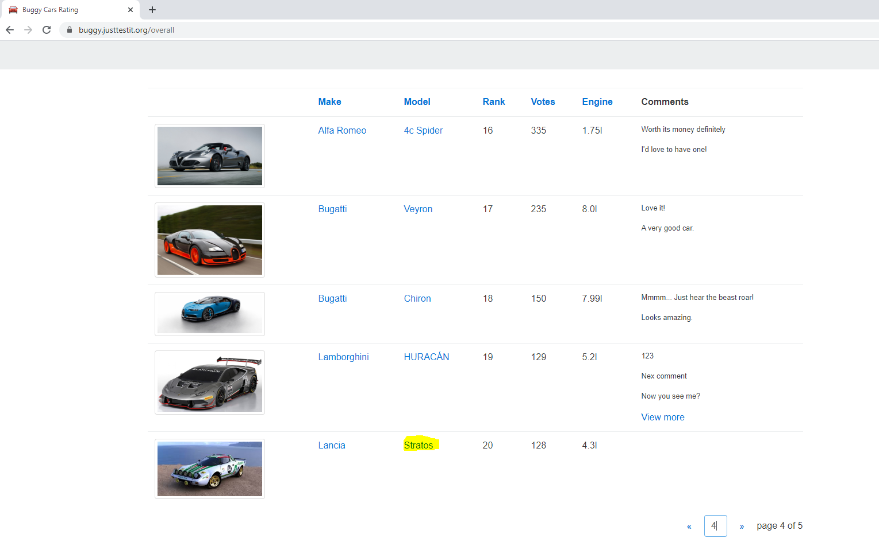

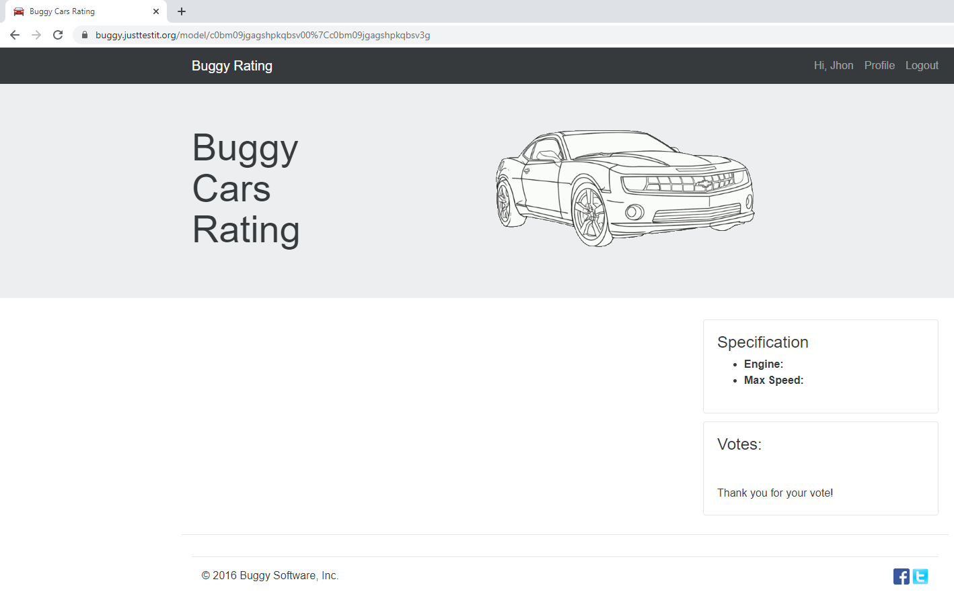

1. **Bug description:** After logged into the website**,** In Profile, under Additional Info
2. Spelling is wrong in "New Pasword" field.
3. After typing first character in New Password field getting a warning message "Passwords do not match" in Confirm Password field.
4. New Password and Confirm Password are supplied with same password as Current Password, it has been accepted and got the message "The profile has been saved successful" rather throwing an error.

